Management Control System

Software Training Materials

**Table of Contents**

1. INTRODUCTION OF MANAGEMENT CONTROL SYSTEM 3

How to Log in the MCS 3

2. FINANCE & ACCOUNTS WING 4

3.MIS PAYROLL MANAGEMENT (SUB MODULE) 5

4.MIS PAYROLL MANAGEMENT MENU OVERVIEW 7

4.1: Settings Menu Overview 8

4.1.1.1: Chart of Account Code (Settings) Add Account Code input field 8

4.1.1.2: Chart of Account Code (Settings) View of details 9

4.1.1.3: Chart of Account Code (Settings) Edit 9

4.1.1.4: Chart of Account Code (Settings) Delete 10

4.1.1.5: Chart of Account Code (Settings) Search 11

# 1. INTRODUCTION OF MANAGEMENT CONTROL SYSTEM

……….

….

…….

…….

…….

Link for MCS is <http://192.168.3.7:3000/> which is accessible within BBA’s local network . After search will open a login page. Which is like –

### How to Log in the MCS

Figure 1: Log in Page

**Steps to Log in MCS**

1. User will input his Username
2. User will input his Password
3. Click Log In Button

If the username & password are correct, users will get access to the system.

# 2. FINANCE & ACCOUNTS WING

For Finance & Accounts module –

**Steps to Enter in Finance & Accounts**

1. After login will show this dashboard of MCS.

2. Click on the Finance & Accounts.

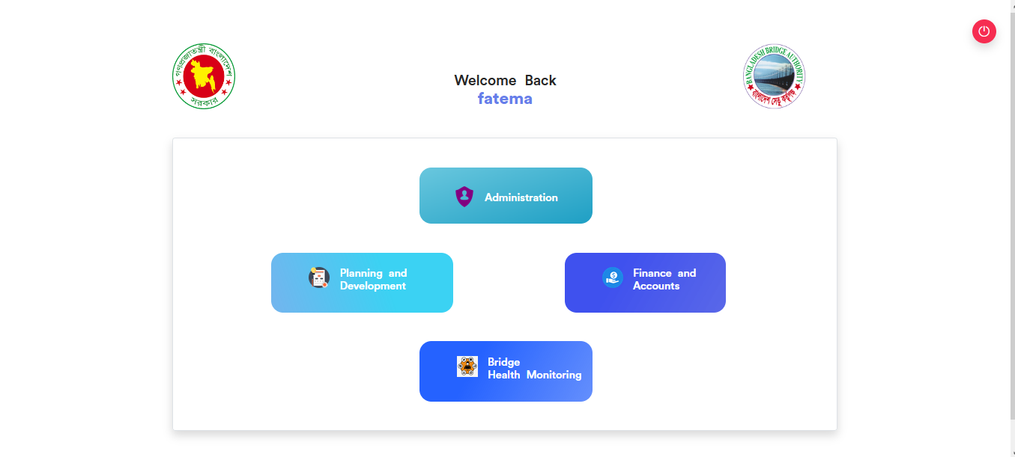

Figure 2.1: Dashboard of MCS

After entering into Finance & Accounts then there will show another dashboard with another four (4) Submodules. Such as-

1.Accounts & Budget Management

2.MIS Payroll Management

3.FDR Management

4.CPF Management

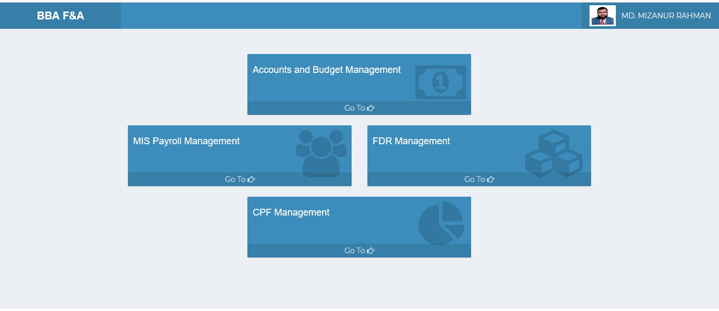

Figure 2.2: Dashboard of Finance & accounts Module.

**Overview of Finance & Accounts Sub Modules**

# 3.MIS PAYROLL MANAGEMENT (SUB MODULE)

After clicking into MIS Payroll Management, it will redirect to the (MIS Payroll Sub Module) dashboard with some menus.

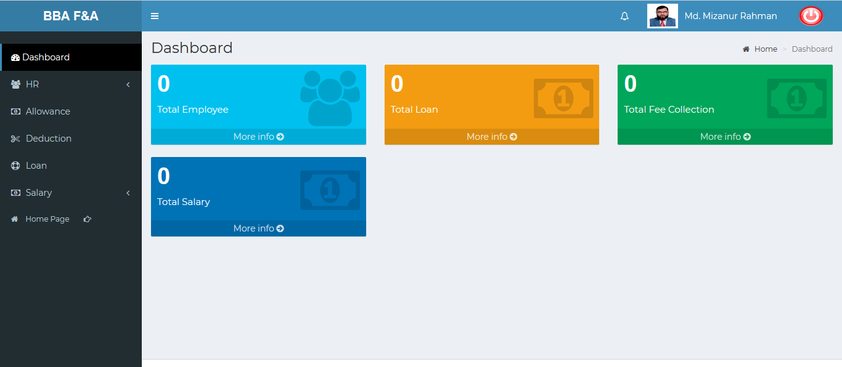

Figure 3: Dashboard of MIS payroll (sub module).

There are four segments on the right side of the MIS Payroll Management Dashboard Such as **Total Employee, Total Loan ,Total Fee Collection** And **Total Salary.**

To get the details info about (**Total Employee, Total Loan ,Total Fee Collection, Total Salary**) just click on the More info link after that it will redirect to the relevant details info page.

# 4.MIS PAYROLL MANAGEMENT MENU OVERVIEW

**MIS Payroll Management Menu Overview**

## 4.1: HR Menu Overview

**Overview of Settings**

Click on the HR menu after that there will appear three(03) sub-menu & they are **Employees , Others** and **Increments.**

### 4.1.1.1: Employees (HR) View of Employees details

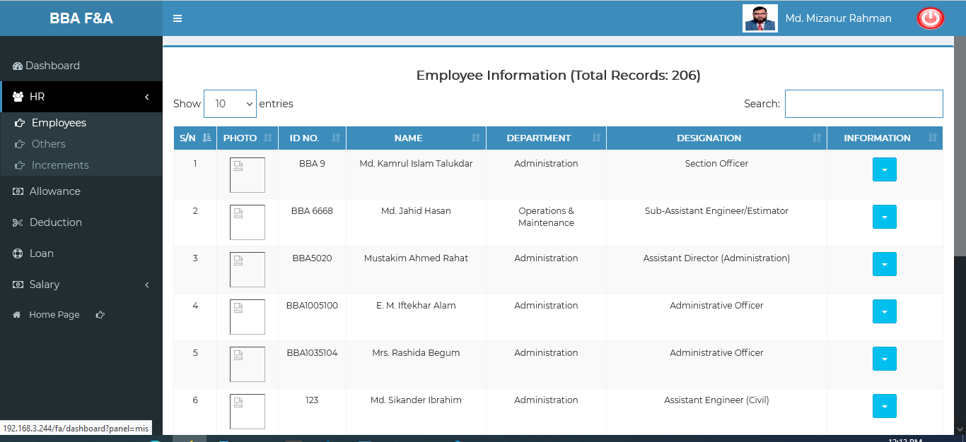

Figure 4.1.1.1: employees(HR) view of employees details

### 4.1.1.2: Employees (HR) View of Employee (Personal) Data

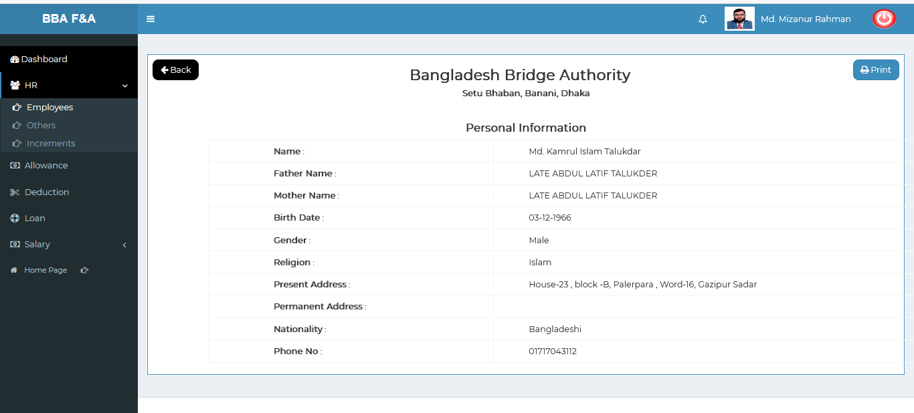

Figure 4.1.1.2: employees (HR)View of employee (personal) data

### 4.1.1.2.1: Employees (HR) Employee (Personal) Data Print

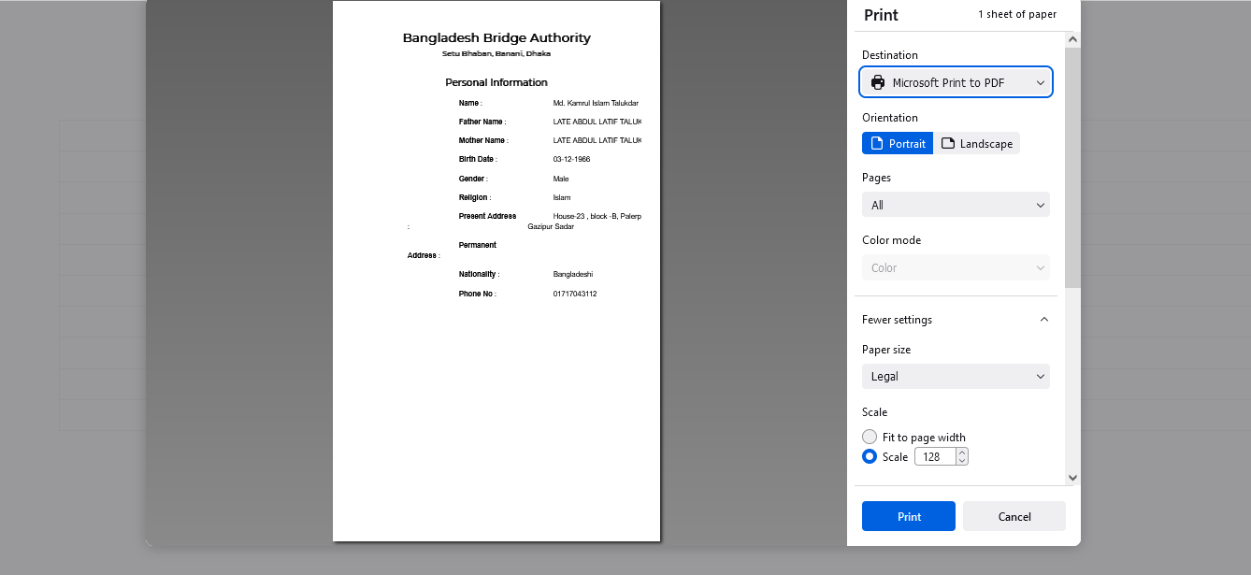

Figure 4.1.1.2.1: employees (HR) employee (personal) data Print

### 4.1.1.3: Employees (HR) View of Employee (Others) Data

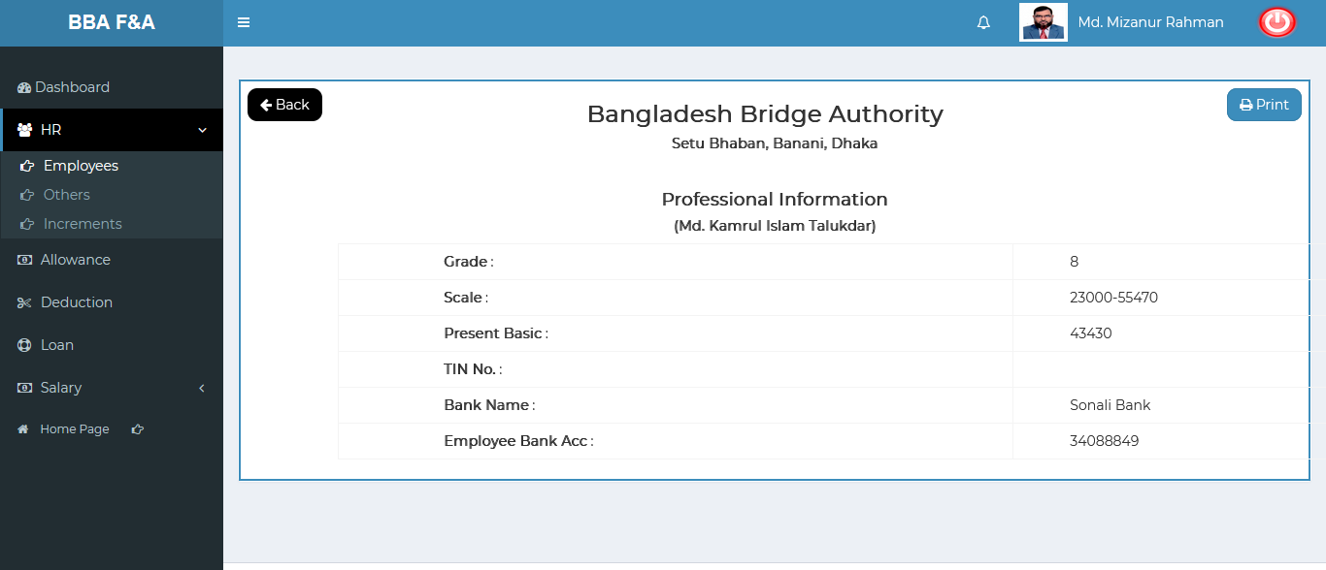

Figure 4.1.1.3: employees (HR)View of employee (others) data

### 4.1.1.3.1: Employees (HR) Employee (Others) Data Print

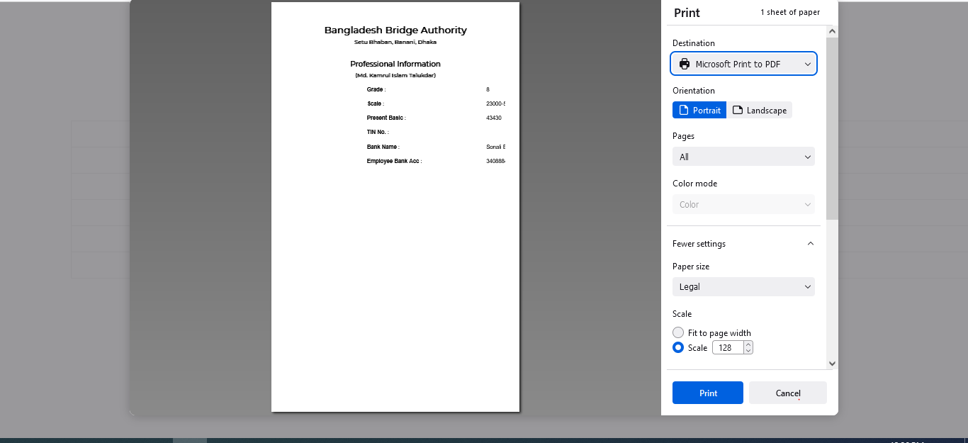

Figure 4.1.1.3.1: employees (HR) employee (others) data Print

### 4.1.1.4: Employees (HR) View of Employee (Increment) Data

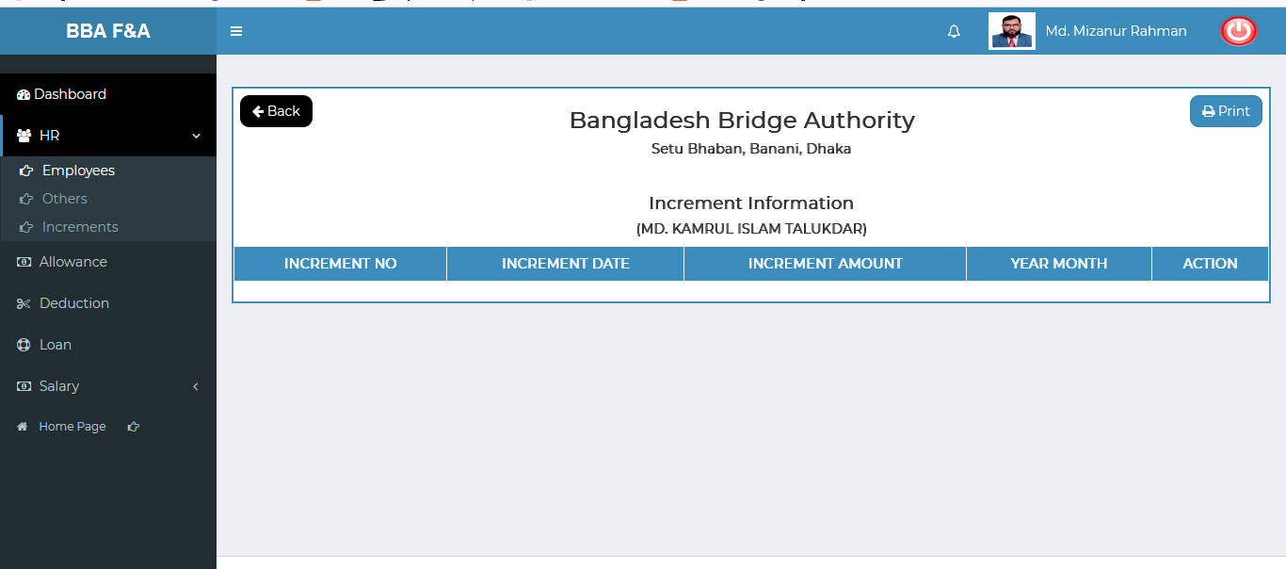

Figure 4.1.1.4: employees (HR)View of employee (Increment) data

### 4.1.1.4.1: Employees (HR) Employee (Increment) Data Print

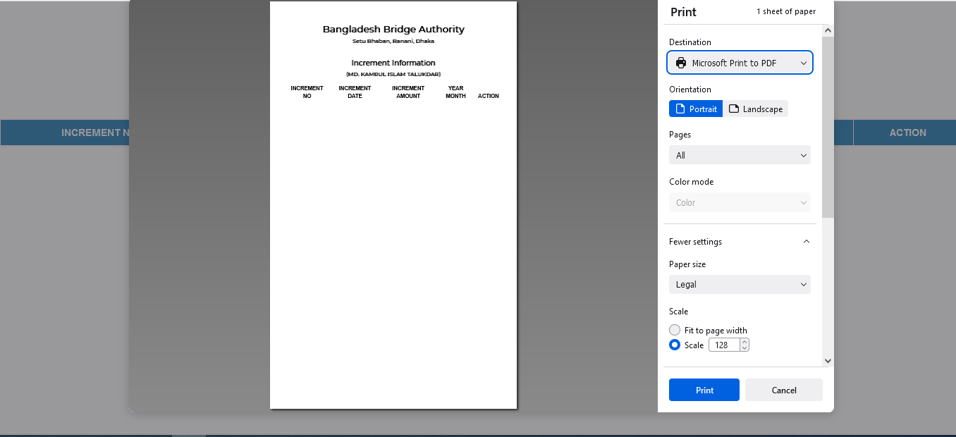

Figure 4.1.1.4.1: employees (HR) employee (increment) data Print

### 4.1.1.5: Employees (HR) View of Employee (Training) Data

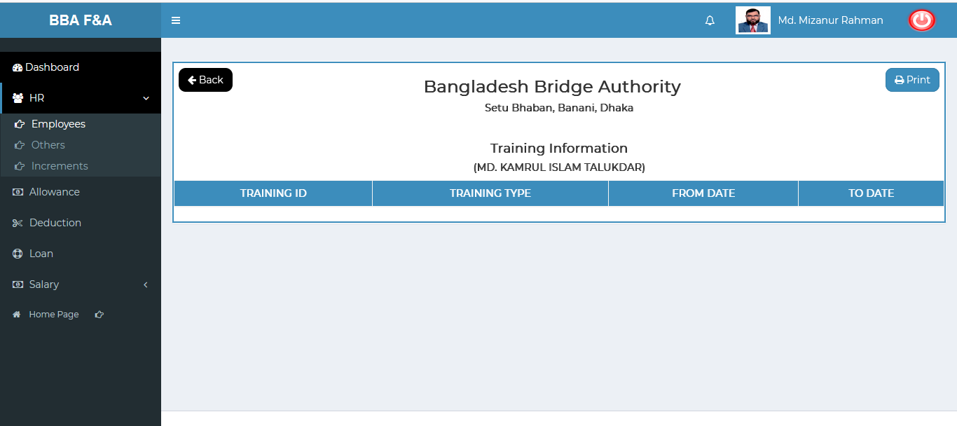

Figure 4.1.1.5: employees (HR)View of employee (Training) data

### 4.1.1.5.1: Employees (HR) Employee (Training) Data Print

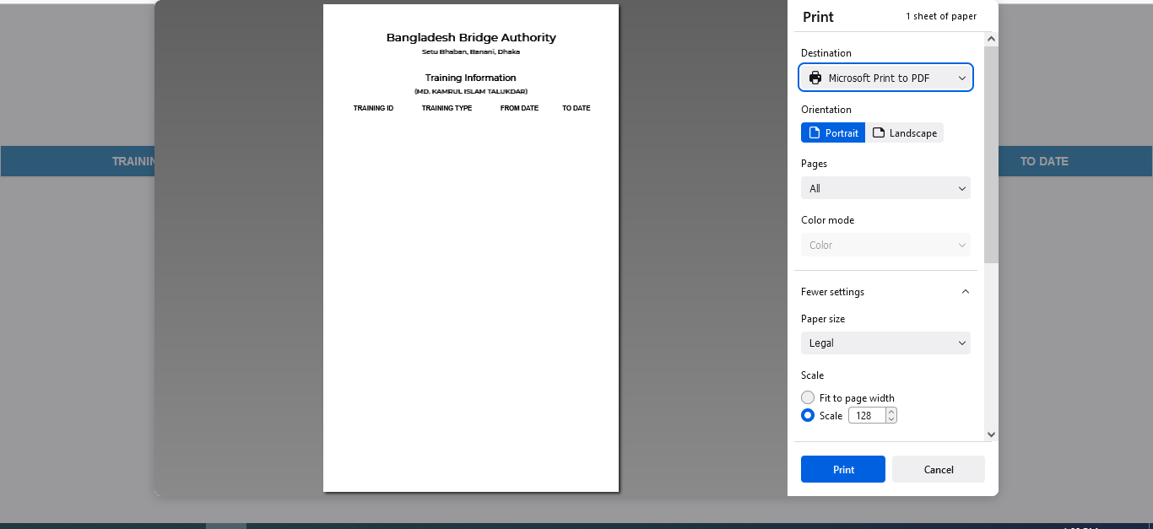

Figure 4.1.1.5.1: employees (HR) employee (training) data Print

### 4.1.1.3: Chart of Account Code (Settings) Edit

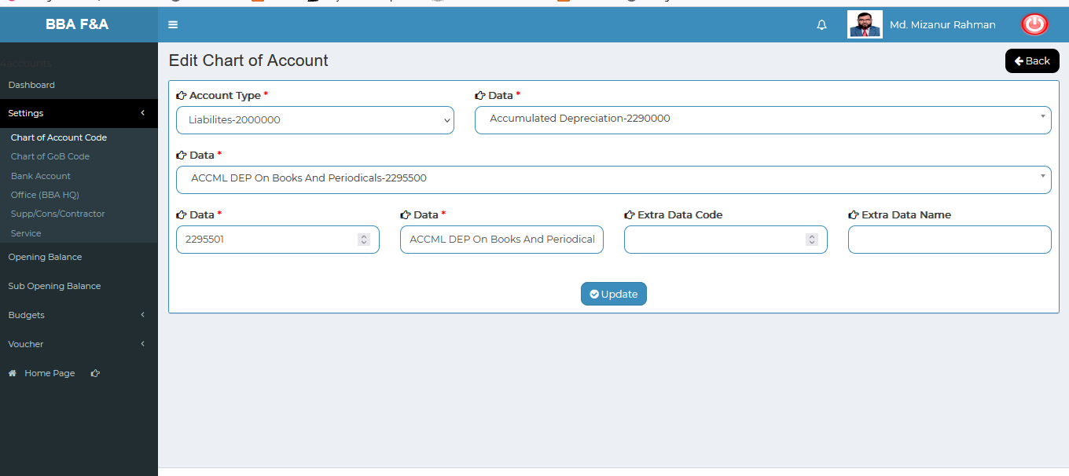

Figure 4.1.1.3: chart of account code(settings)View of details

### 4.1.1.4: Chart of Account Code (Settings) Delete

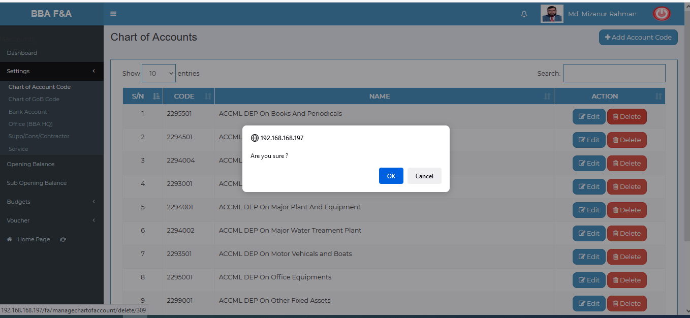

Figure 4.1.1.4: chart of account code(settings)delete

### 4.1.1.5: Chart of Account Code (Settings) Search

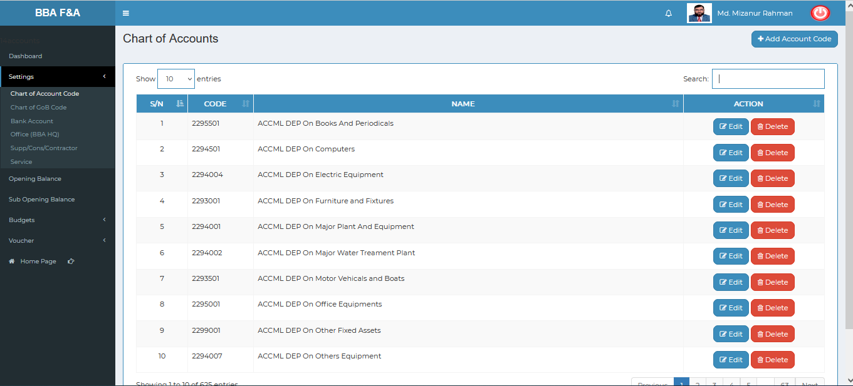

Figure 4.1.1.5: chart of account code(settings)before search

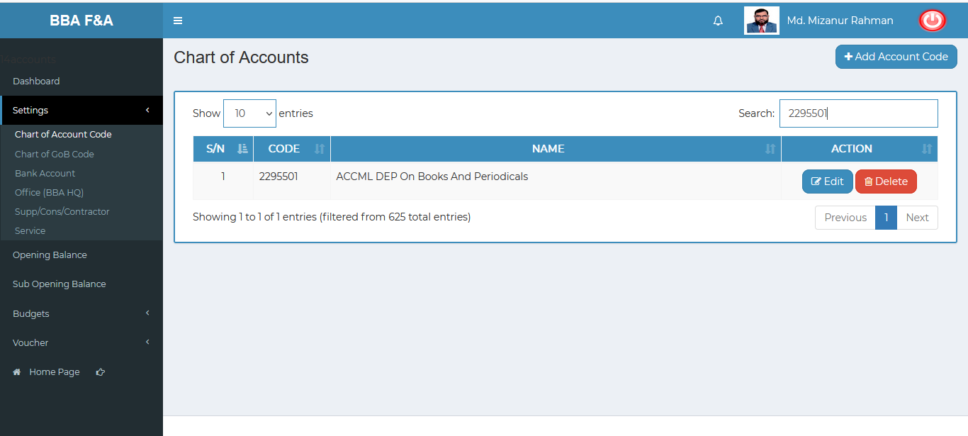 Figure 4.1.1.5: chart of account code(settings)after search